Uploading documents with the eDoc Uploader.


ms]
Double click the eDoc Uploader icon from your desktop or, if it's not on your desktop, from the All Programs menu system.
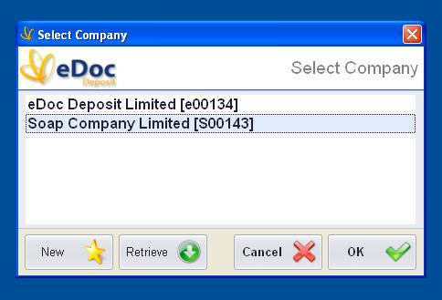
First you will need to register with eDoc Deposit. From the Select Company screen click on the “New button”. You will be directed to the online registration page at www.eDocDeposit.com.

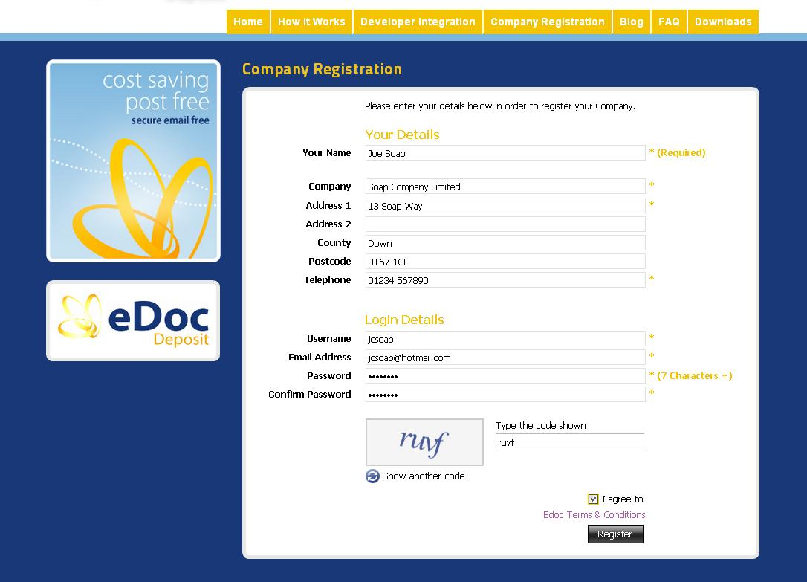
Complete the registration page as shown above.You will be required to enter a password please be sure to remember this as it will not be shown again, you will also need to agree to the terms & conditions. Keep your password secret as all documents uploaded to your account using your reference and password will be charged to you.

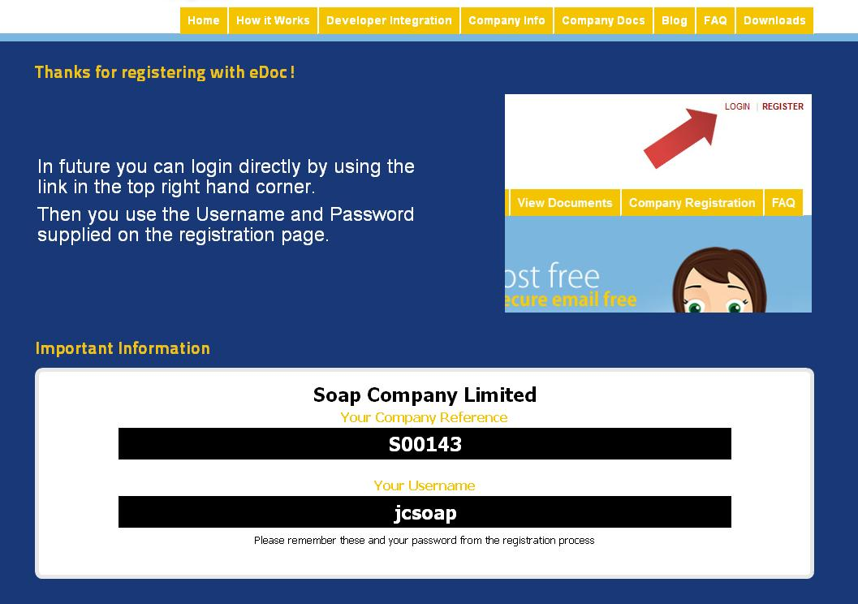
Once you have completed the registration you will issued with a Company Reference, which will be displayed along with with your Username. Your password will the one you keyed and will not be displayed. Please take a note of your Company Reference you will need it later.
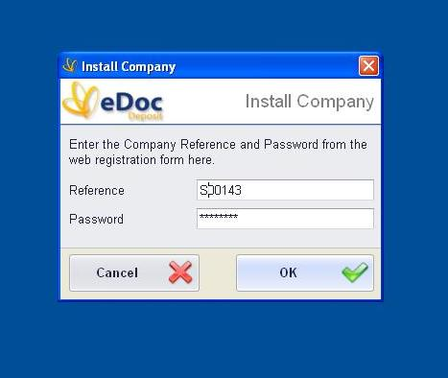
Exit your browser and enter the Company Reference and Password in the Install Company screen. Then click on the “OK” button.
Your newly registered Company should now appear on the Select Company screen, you will probably only be showing one company. Highlight the required company and click on the “OK” button.
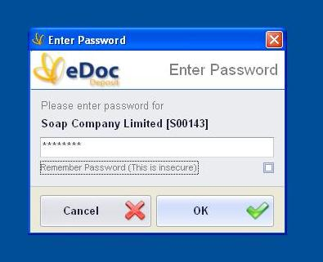
Enter the password you entered during the registration process and click the “OK” button. You can, if you wish, tick the remember password box so that you will not need to enter the password again but remember this is less secure.

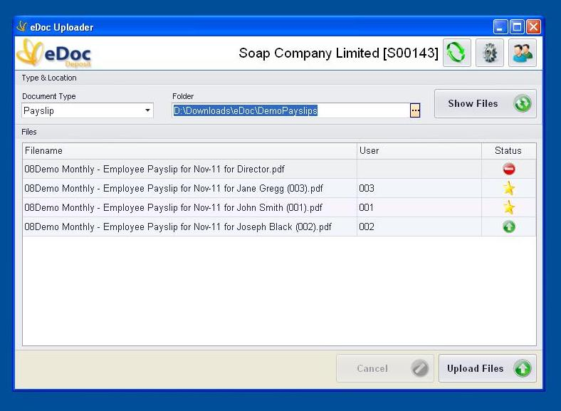
Select a document type from the Document Type dropdown, I have choosen Payslip for the example above. Choose the folder where you have previously placed the documents you wish to upload and the documents waiting to be uploaded will be displayed. If the documents aren't being displayed click the “Show Files” button or check that the documents are where you expect them to be. It is important to be aware that once the documents have been successfully uploaded they will be deleted from the upload folder. If you need to keep a copy for your own records then you must keep a copy in another folder.
The uploader will look for a user ID enclosed with brackets in the filename and it will use this user ID to store the document against the correct user, in the example above these are employees. It is important that the user ID is unique, the uploader will use the user ID to store documents against the correct user.
For each document in the upload folder you will be shown the Filename, the User and the Status. The filename is just the name of the document, the user is the user ID contained within brackets in the filename and the three statuses are described below:
- Red No Entry symbol means the document does not have the user ID contained with the filename and consequently the document will not be uploaded.
- Yellow Star symbol means this is the first document that has been uploaded for this user so a new user will be created and the document uploaded.
- Green arrow symbol means this user already exists and document will be uploaded to their account.
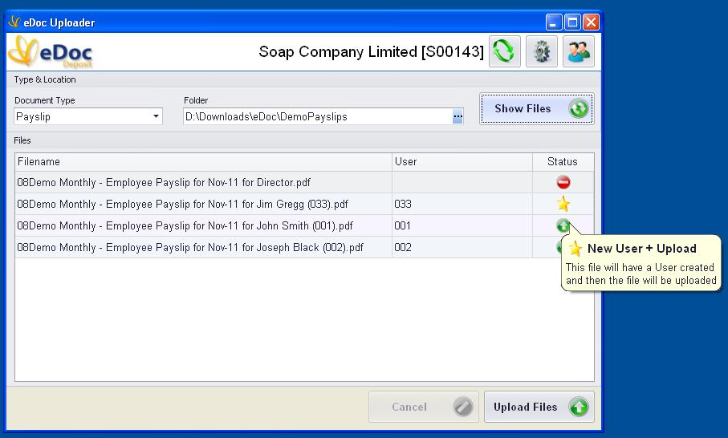
To see a description on the Status just roll the mouse pointer over the symbol and a brief explanation ( tool tip ) will be shown, as above.
When you are ready simply click on Upload Files and your documents will be uploaded for you. In the example above the payslip for “Director” has no user ID included in the filename and so cannot and will not be uploaded. To have this document uploaded the filename would have to be changed. So for example “Director” could be changed to “Director (055)”, the document would then be uploaded to user ID 055.

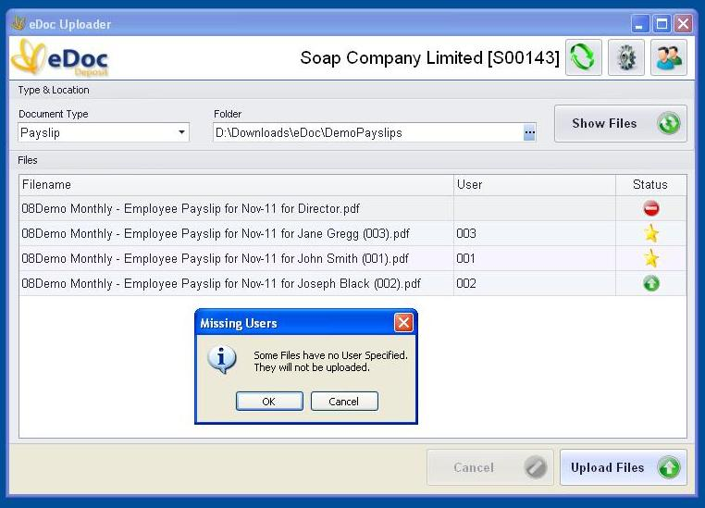
The message above will be displayed if some documents have no user ID.
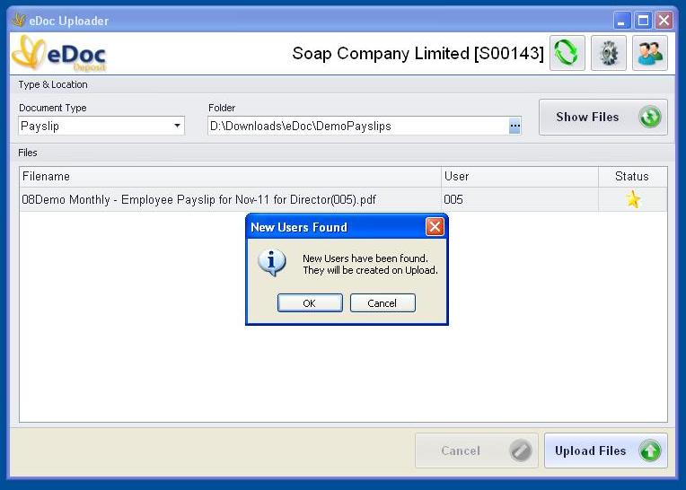
The message above will be displayed if there are any new users.

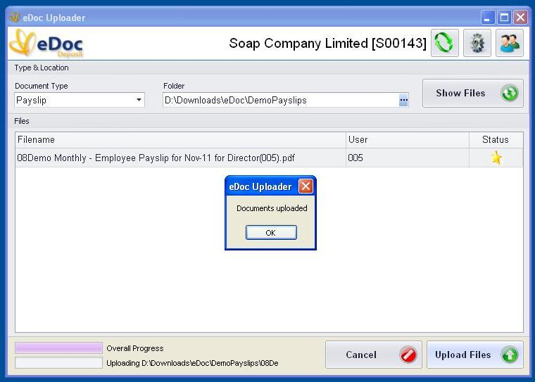
Once the documents have been successfully uploaded the message above will be shown.
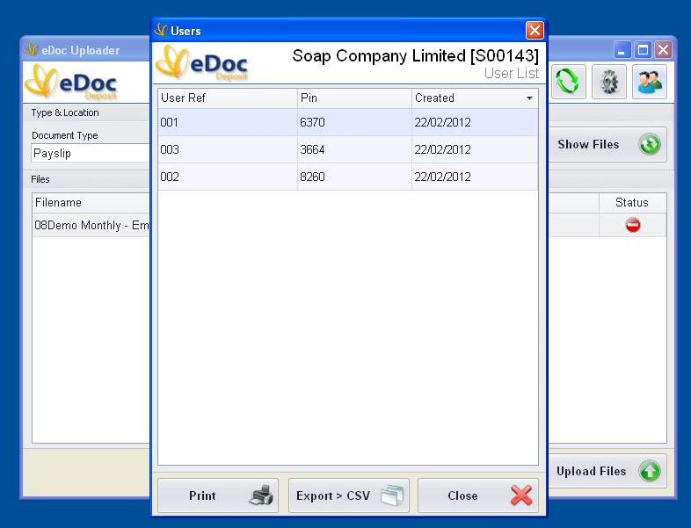
A list of users and their PIN's can be shown by clicking on the show users icon on the top right hand corner of the form. Users will need their username and PIN to successfully download their documents.

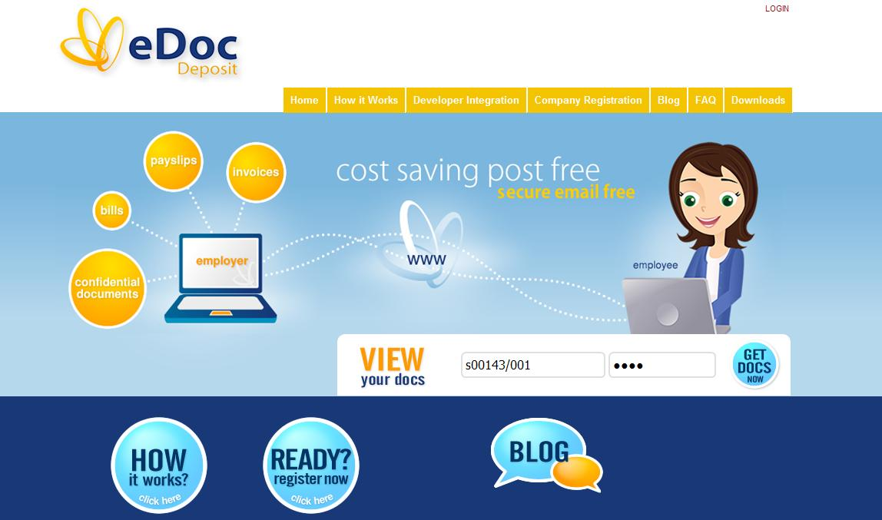
Users can download their documents by visiting the eDoc Deposit web site at www.eDocDeposit.com and entering their username and PIN. Their username is the Company reference / User ID and the PIN can be obtained from the list of users. So for one of the above users the username and PIN would be as follows:
Username : S00143/001, PIN : 6370
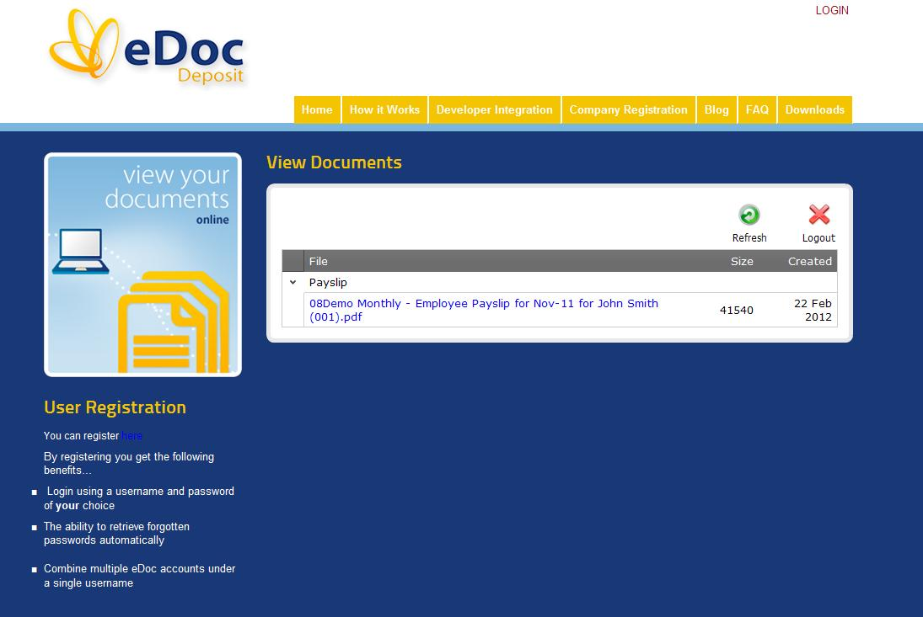
Once the username and password have been correctly entered the user can see a list of documents on his account. To download all they need to do is click on the required document.

